Annual General Meeting 10th June 2025
1930 Small Hall, Cove Burgh Hall
Minutes
Fire Regulation Notice
- Attendance including apologies
John Auld (Convenor), Kenny Barlas, Susannah Conran, Nick Davies, Derek Fowlis, Sheena Lamont,. James McLean Lynda McKenzie, Ellen McVey, Ali Mills Christine Murdoch, Sheelagh O’Reilly (Secretary), , Anne Strachan (Treasurer),
Apologies: Kathy Gostick, Cllr Shonny Patterson; Cllr Mark Irvine
- Members of public including one member of the press
- Declarations of Interest: None
- Adoption of the Cove and Kilcreggan Community Council AGM Minutes from 11 June 2024. The minutes of the meeting held on the 11 June 2024 were adopted. Proposed C. Murdoch / N. Davies
- Convenors Annual Report and questions from the floor. Report previously circulated – see attached. No questions were raised.
- Secretary’s Annual Report and questions from the floor. Report previous circulated – see attached. No questions were raised.
- Treasurer’s submission of Balance Sheet and Annual Accounts duly independently examined and certified correct, and questions from the floor. Report attached and no questions raised. The Community Council specifically thanked the treasurer for her work and also wished to thank our independent examiner Anne Bernard.
- Election of Office Bearers
a) Vice Convenor: Christine Murdoch proposed by Nick Davies and Sheena Lamont.
b) Hon Treasurer: Anne Strachan proposed by John Auld and Christine Murdoch
c) Convenor: John Auld proposed by Derek Fowlis and Christine Murdoch
James McLean wished it to be noted that in his view it was not appropriate for someone owning development land to be the Convenor of the Community Council. It was noted that the CC has an agreed Declaration of Interest policy and that would ensure appropriate actions were taken in the event of an interest being declared.
d) Hon Secretary: Sheelagh O’Reilly proposed by Christine Murdoch and Sheena Lamont
8. . Dates of Community Council meetings 2025/26
These had been previous circulated (attached) and agreed at the community council held on the 8th April. Changes made to ‘odd’ months so that more meetings would be held outside school holidays. Time changed to 1915 start. CBH to be notified. Next meeting will then be held on the 8th July with the AGM in 2026 on the 9th June prior to the start of the 2026 Community Council elections.
It was also agreed that Community Council meetings will commence at 1915. The Secretary will send the agreed dates and time change to the CBH bookings team.
9. Any other competent business: none raised

Convenors report for year to June 25
Prepared 6th June 2025

It has been a busy year with a range of meetings. It has been good to see the results of the work of Our Community. It is also great to see that the groups from this process are now taking off. We should recognise the role and work of the many volunteers needed for this work. Praise to all and certainly I note the efforts of the beach cleans in collecting a very sizable amount of rubbish

This work highlights that the strength in the villages is the community. Their participation in many aspects of local life and collectively bringing people to work together for results, and listening to their needs is imperative. We also are increasingly aware of the continued tightening of resources from A&B Council funding (and other sources), which I feel is the biggest challenge in the community currently. Connectivity and working positively with A&B Council more widely and not just our local councillors, to get results is essential. This can then bring benefits to people. In some areas we are starting to see the dialogue connect and we have to understand this will still take some time to see fruitful results, and in some areas there is still much to do in this. A&B Council also needs to be clearer on stating when it cannot do work or resource the work or services within the community. The CC and the community need to work with realistic expectations so that we can look at addressing issues of local importance in a range of different ways.

We will also need to factor in that this area will eventually see significant changes stemming from the UK Government Defence Spending Review. This will eventually have an impact on the whole community in some way, so we need to be vigilant in the opportunities of keeping our healthcare our education , housing and our transport links all working well for us all. Hopefully we can all work together on this as we go forward

Also, all members must be thanked for their participation and all the work they do without which the various views of the community would be much depleted

Secretaries report for the 12 months to 10th June 2025
Prepared: 6 June 2025
The last 12 months have been busy and included work preparing for, and responding to actions for 1 AGM and 6 normal Community Council meetings. Follow up letters / actions circulated to members and discussed, where appropriate, at the following meeting.
Prepared for the Community Council a list of outstanding works in relation to paths, lighting, flood areas, Kilcreggan Shelter and more. Sent to A&B Council and CC members have taken forward in relation to Kilcreggan. The CC again had to remind A&B Council they they do have ‘ownership’ of the Kilcreggan Shelter as per Argyll & Bute Land and assets Register: https://argyll-bute.maps.arcgis.com/apps/webappviewer/index.html? id=4426b461ba6d4e4c8d69937b07218096 Currently the CC (nor any other body) does not hold a specific register of community assets and their ownership for the C&K area.
C&K Community Council received two grants in the last 12 months:
- £1000 for work at the Peaton Community Nature Reserve for the ‘outdoor classroom’ renovation and access. The work was delayed due to the effects of Storm Eowyn and the number of trees that blocked access. The site has now also been ‘adopted’ by Rosneath & Clynder Community Council as it formally sits in their area but is widely used by residents of C&K, the Peninsula and beyond.
- £2,250 for work related to Community and Household Emergency Planning. £1000 was given to Kilcreggan Primary School to support their work (in two terms) around building Resilience. This grant runs to December 2025 and work will continue on the delivery of CHEP.
The Secretary has attended a number of the Helensburgh & Lomond Community Planning Partnership meetings held in Helensburgh. An opportunity to meet other people from other community councils and key service delivery / third sector agencies. These meetings have also enabled follow up on issues of the RTS switch off at the end of June and the Digital Switch / Telecare issues.
The Secretary continues to post on Facebook – primarily events and notices including road closures, health related meetings, electric meter switch off and Telecare issues. Also used for events such as PNR Working Parties / Beach Cleans etc. Useful resource with now close to 1000 followers.
The Secretary continues to use the Website for posting formal documents e.g. minutes / agendas which cannot be posted through Facebook i.e. a useful archive. We have a ‘live’ email related to the website which is used by members of the public (issues with motorhome parking, where to get planning info, lost phones….) and quite a lot of junk mail! Review of the use / purpose of the website is ongoing and striking a balance between low cost and professional maintenance seems to be a challenge!
Work on CHEP is proceeding slowly and the Secretary attended a meeting near Colintraive regarding Storm Eowyn issues and responses. Clear evidence that having a community hall e.g. CBH makes responses to disasters much more effective!
Accounts as presented
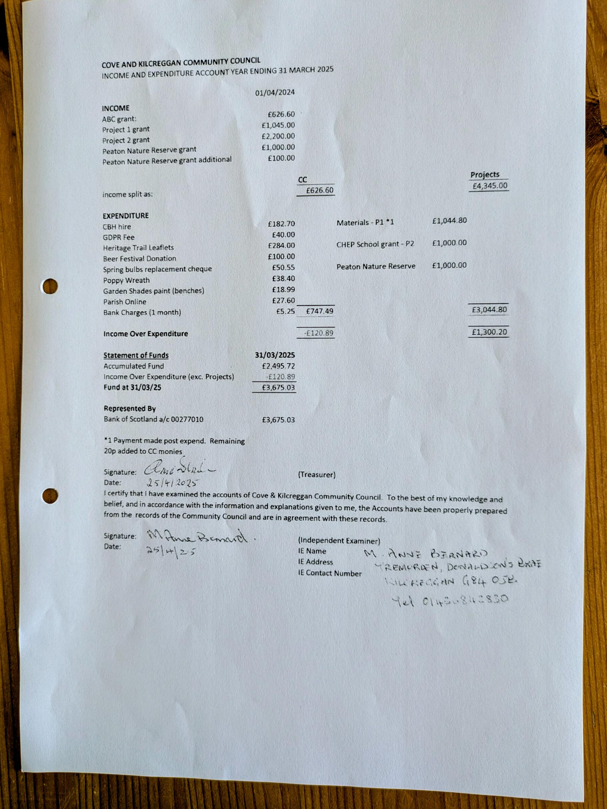

Agreed dates for Community Council Meetings for period to December 2026
Every second month on second Tuesday of the month (odd months) PLUS AGM in June. (7 Meetings a year)
Date | Comments
2025
10 June | AGM & CC Meeting
8 July | CC Meeting (School Holiday)
9 Sept | CC Meeting
11 Nov | CC Meeting
2026
13 Jan | CC Meeting
10 Mar | CC Meeting
12 May | CC Meeting
9 Jun | AGM & CC Meeting
14 Jul | CC Meeting (School Holiday)
8 Sept | CC Meeting
10 Nov | CC Meeting

Note that dates are reviewed at each AGM (June) and that there are elections in summer 2026 and the new CC members may wish to vary the dates after the election.

