Annual General Meeting 11th June 2024
Minutes
NOTE: These minutes are for agreement and will then be formally adopted at the next AGM on the 10th June 2025.

- Fire notices.
- The following community councillors were present: John Auld (Convenor), Kenny Barlas, Susannah Conran, Nick Davies, Sheena Edwards (Treasurer), Derek Fowlis, Sheena Lamont, Ali Mills (Vice Convenor), Lynda MacKenzie, James McLean, Christine Murdoch, , Sheelagh O’Reilly (Secretary), Anne Strachan.
- Members of the public including the press. Julian and 2 members of public
Apologies: Kathy Gostick, Ellen McVey, Cllr Shonny Patterson, Cllr Mark Irvine
- Declarations of Interest - None
- Adoption of the Cove and Kilcreggan Community Council AGM Minutes from 13th June 2023. The minutes were adopted (Nick Davies / Derek Fowlis).
- Convenors Annual Report and questions from the floor
- Key point from a busy year were the increased use of the Community Council website for sharing of documents and related material. More recently use of Facebook to have a more immediate engagement with those who follow social media.
- No questions from the floor.
- Secretary’s Annual Report and questions from the floor
Report attached below. It is recognised that the number of emails can be high but this does help to ensure all members of the CC are informed of issues coming up, training opportunities and concerns from the community.
- Treasurer’s submission of Balance Sheet and Annual Accounts duly independently examined and certified correct (and questions from the floor).
Report presented below and had been previously circulated to the CC members and published. Key point is that the bus account is now closed so that the CC has a single account.
The accounts were adopted (James McLean / Kenny Barlas). It was also agreed that once the AGM minutes have been agreed the CC will submit them to A&B Council to request payment of the 2024/5 administrative funds.
- Election of Office Bearers

- Convenor
Two candidates were proposed for Convenor.
- John Auld nominated by Derek Fowlis and Christine Murdoch
- Anne Strachan nominated by James McLean and Ali Mills.
It was noted that Anne Strachan said her primary reason for standing was seeing the most appalling behaviour at the last Community Council meeting, which was embarrassing given this was a public meeting and at no time was this behaviour admonished or stopped.
James McLean who nominated Anne Strachan for convenor made the following statement: “This is not personal, but following the implementation of LDP2 in February John Auld is now the owner of development land and I don’t think it is appropriate nor ethical that he holds the position of convenor in our CC. It is also not a good look for our CC”
A discussion was held concerning issues raised by James McLean regarding John Auld and land that is identified in LDP 2 as for housing development. Discussion on issues of non-discrimination including input from Cllr Corry. The Declaration of Interest process is designed to address publicly any issues of actual or perceived Conflicts of Interest.
It was agreed that a vote would be held although there was concern about the process and knowledge around the two candidates. The CC agreed that Cllr Corry would chair the vote and that the two candidates would leave the room. A show of hands was taken and the vote was:
John Auld – 6 votes
Anne Strachan – 5 votes
It was therefore agreed that John Auld would continue as Convenor for 2024/25.

- Vice Convenor
It was proposed that Christine Murdoch be Vice Convenor (Derek Fowlis / Sheelagh O’Reilly). No other nominations were received therefore Christine Murdoch was appointed as Vice Convenor.
- Hon. Secretary
It was proposed that Sheelagh O’Reilly be Honorary Secretary (Nick Davies / Sheena Lamont) No other nominations were received therefore Sheelagh O’Reilly was appointed as Honorary Secretary.
- Hon. Treasurer
It was proposed that Anne Strachan be Honorary Treasurer (John Auld / Sheena Edwards). No other nominations were received therefore Anne Strachan was appointed as Honorary Treasurer.
- Dates of Community Council meetings 2024/25
Previously all CCs had been presented with 4 options regarding dates of meetings ranging from 6 meetings a year on either even or odd months, 12 meetings a year or 10 meetings (not Jan or July). The CC members voted for a continuation of the existing pattern of meetings. It was noted that a number of the dates were in school holidays and concern was raised that this may exclude people with school age children.
Two options were discussed and voted on:
Option A: Hold next meeting as planned on the 13th August and then move to meetings on the second Tuesday of the odd months (Sept / Nov / Jan/ March / May with an AGM in June).
Option B: Hold meetings as currently i.e. the second Tuesday of the month for even months.
The vote was decided by a casting vote from the Convenor to stay with the current meeting timings i.e. Option B. This can be reviewed again prior to the 2025 AGM.
The agreed dates are presented below.
9. Any other competent business
Nothing was raised.

Cove and Kilcreggan Accounts Approved 11 June 2024
Prepared the Sheena Edwards, Treasurer for the AGM 11th June 2024
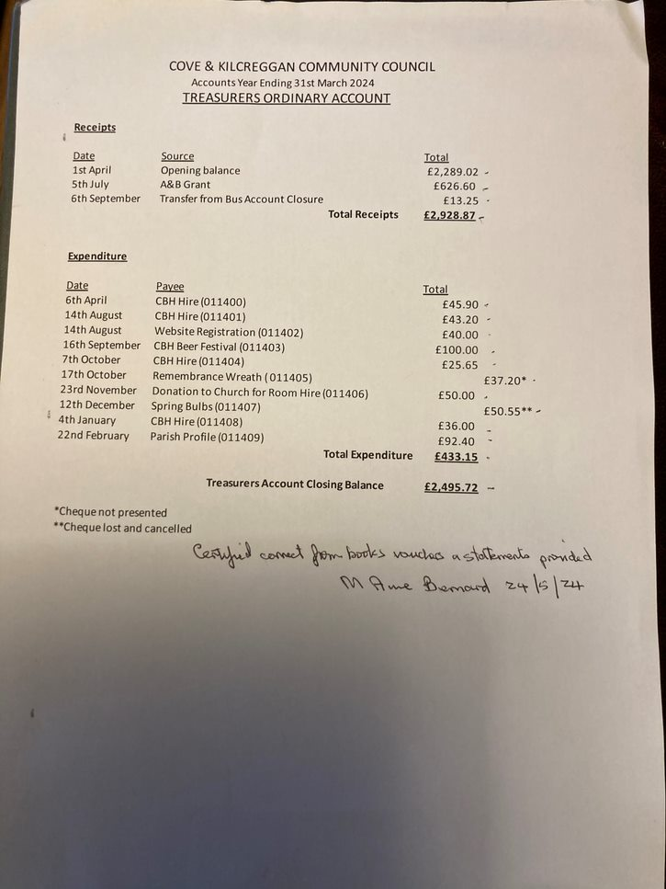

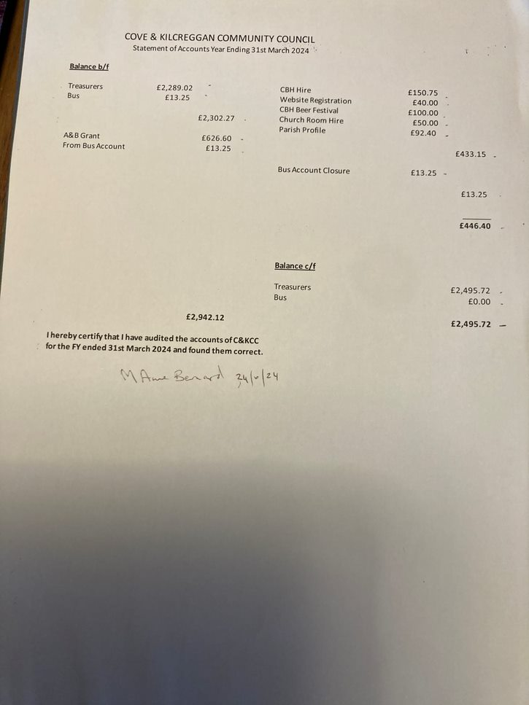

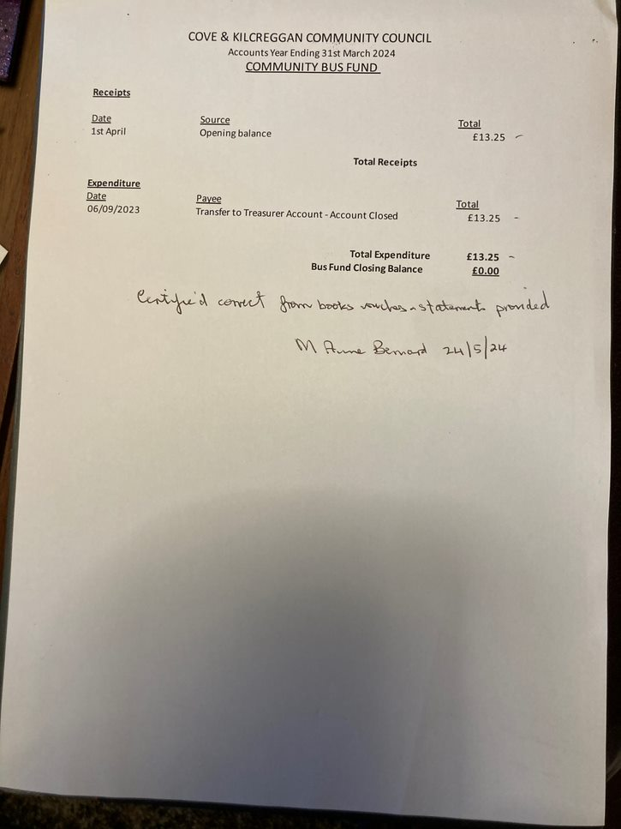

Annex: Cove and Kilcreggan Community Council: Report of the Secretary
For AGM 11th June 2024
The year June 2023 – June 2024 has been busy with the following (not an exhaustive list):
- 6 formal meetings plus the AGM. Minutes prepared, agreed and circulated to members, A&B Council, Elected Councillors and posted on the website and put in Cove Library.
- Notifications of meetings are circulated as above and also posted on Facebook.
- Managed the C&K website which is now used for more ‘formal’ notices as the Secretary can now administer the Facebook page. The latter has an immediacy and is used for more urgent communications including notifications (which the CC now receives) of road closures, tracking deer and highlighting beach cleaning opportunities.
- Letters requested by the Community Council re planning matters sent following meetings and, responses circulated to CC members.
- Attended several online training courses (details circulated to all members) on a range of matters and any material / video of the training also circulated to CC members for information. This has included Local Place Plans, Met Office on Climate Change, Participation Request Process and wider planning issues provided by A&B Council.
- Attended, with the Convenor, the HMNB Clyde community liaison meeting.
- A small CC working group obtained a grant from the National Resilience Centre (University of Glasgow) to support the work of the C&K Community and Household Emergency Planning. Work is ongoing and an application for funding was made to the A&B Council Communities Grant for additional funding – including work with Kilcreggan Primary school. Decision on this grant due on 11th June. The CHEP team held a number of informal sessions, a formal meeting in January 2024 (attended by our local MP) and a leafleting campaign in January.
- Acted as the focal point for a range of organisations who want their material circulated more widely to communities. This includes the Argyll & Bute Climate Action Network, Living Well Team and the A&B Council Community Development Team. The latter will be holding a meeting of H&L Community Councils on 6th June which the Secretary hopes to attend.
- Formally prepared documents for the CC approval on:
  - GPDR
  - Planning application management processes
  - Updating of the Declaration of Interest process (for agreement at the CC meeting on 11th June)
- Provided a ‘point’ for liaison with A&B Council regarding their allocation of funding for the repair of the Cove Play Park.
- Visited a number of households who have been affected by flooding in 2023/24 (some whilst conducting the CHEP leafleting) to see the scale of flooding across the C&K area (and more widely on the Peninsula). The issues are immediate, but resolution is likely to be complex. Written to A&B Council regarding ways to design and implement a flood prevention / mitigation plan but awaiting response.

Annex: Agreed Meeting Dates for Cove and Kilcreggan Community Council June 2024 – June 2025

The agreed meeting dates through to June 2025 are as follows:
Proposed CC dates: every second month on second Tuesday of the month for even months
2024
11 June 2024
11 June 2024  AGM | Needs to be held annually. Focus on election of officers and agreement of accounts and dates for CC meetings.
13 August 2024 | In School Holidays
8th October 2024 | In School Holidays
10th December 2024
2025
11th February 2025 | In School Holidays
8 April 2025 | In School Holidays
10 June 2025
10 June 2025 AGM | Needs to be held annually. Focus on election of officers and agreement of accounts and dates for CC meetings.

The Community Council has the following process regarding management of Declarations of Interest of all types, including in relation to LDP2. - The issue of the Convenors ownership of a parcel of land identified in LDP2 for development was discussed with A&B Council and the following Declaration of Interest was made at the CC meeting held on the 8th August (minutes available at ( https://coveandkilcreggan.org.uk/documents/ck-community-council-minutes-of-meeting-held-on-8th-august-2023/) and subsequent meetings: The following statement was made by the Convenor: As the new convenor I have had discussions with the Governance Officer at Argyll and Bute Council regarding my ownership of land that is identified for possible development in LDP2. LDP2 forms part of Argyll and Bute Council’s statutory plans for the area and is in the process of being adopted by them. As the land owner for one parcel of land I would follow the current guidance on Declarations of Interest and would not chair the section of any CC meeting dealing with issues specific to that parcel of land. - LDP2 is available to view through the following link to A&B Council website: https://www.argyll-bute.gov.uk/planning-and-building/planning-policy/local-development-plan-2 - The C&K CC revised Declaration of Interest is available at: https://coveandkilcreggan.org.uk/documents/ck-community-council-revised-declaration-of-interest-policy-11-june-2024/

