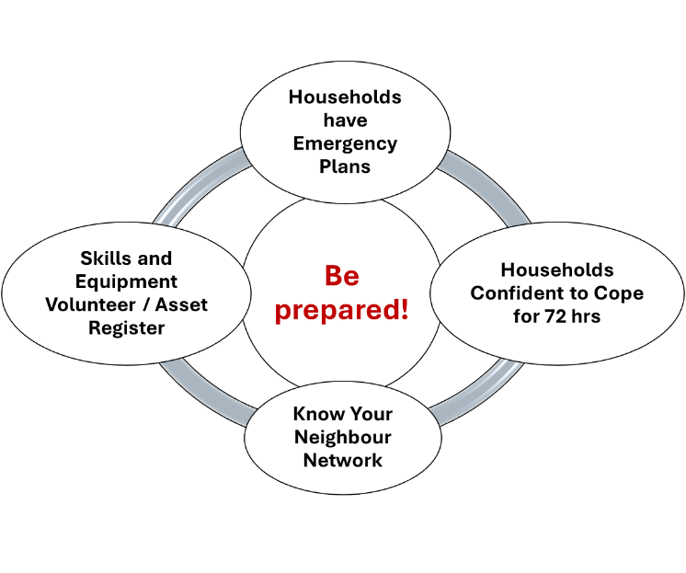
Report of the Cove and Kilcreggan Community Council ‘Drop-In’ Session on Community and Household Emergency Planning: 13 January 2024

Building on the two ‘informal’ events held in the Bus Shelters of Kilcreggan (21st October) and Cove (28th October) and the leafleting undertaken in early January 2024, a ‘drop-in’ event was held on the 13th January 2024. The meeting was held in the Small Hall of Cove Burgh Hall with a focus on:
- Looking at issues (flooding, blocked gulleys, possible volunteer networs) within 9 areas from Peaton to Portkil;
- Starting to build the volunteer network,
- Increase local households knowledge of emergency planning (plan for the worst and expect the best!) for natural hazards such as flooding, large scale power outage.

There was an estimated attendance of around 50 people during the event – great for a sunny Saturday morning! The National Centre for Resilience at the University of Glasgow representative joined us for the meeting and had a number of interesting discussions with residents. We also welcomed our local MP (resident in our area) for an extended visit and express thanks for his highly engaged discussions of the issues.
The table below highlights some of the issues raised from the 9 areas within the Peaton to Portkil area. Following the table is a list of future actions which we hope to address (in full or in part) over the coming months.
Table: Area and identified issues (to be added to during 2024)
Area | Location | Identified issues
1 | Portkil & Fort Road to Kilcreggan | - Fort Road Lochan impedes access to the village in heavy rains. Issue of depth etc. This is linked to challenge of the road completion and Fort Road development.  - Road also challenging to see in bad weather – perhaps the need for ‘snow-poles’ to guide drivers.
2 | Kilcreggan Village to School Road | - Donaldsons Brae – water run off during heavy rain. Drains often blocked leading to significant water across Shore Road.  - School Road between Shore Road & Argyll Road junction. Road floods/ manhole covers off / road collapsing / raw sewage on road.  - Power outages. Support for homes and businesses?  - Maintenance of overhead cables that run through or near woodland  - Loss of fresh water – supply point  - Fairfield gardens – drain at school floods garden / path.
3 | School Road to North Ailey | - Road from CBH to Craigrownie church constantly flooding.  - Raw sewage constantly flowing from recreation group  - Rockingham – surface water drain to beach  - Gully clearance and emptying of bins so debris is not scattered around blocking drains
4 | North Ailey to Blackstone | No comments written
5 | Blackstone to Eilean Beag | No comments written
6 | Eilean Beag to Barbour Wood | No comments written
7 | Barbour Wood to Ardpeaton | No comments written
8 | Ardpeaton to Craigpeaton | Lochview and surrounding area:  - Lochview flooding due to geography and specifically lack of suitable drainage and blocked ditching. Council have raised a ‘low priority’ job for 100m of ditching and 40 metre at junction with Peaton hill.  - Lochview – Barbour Road. Speeding – no 30 mph limit. Road at national speed limit.  - Road surface Barbour Road breaking up at sides and all passing places are not suitable, too low scraping bottom of car on existing passing places, pot-holes at rear Cove Park too.
9 | Craigpeaton to Coulport | No comments written.

Future Actions
The work of the Community and Household Emergency Planning (CHEP) has just begun. We will continue working in the coming months with a focus on:
- Building the ‘Know Your Neighbour network’ across all locations from Peaton to Portkil,
- Continue to stress the ‘Confidence to Cope’ idea for individual households and their specific needs:
  - use of ‘what3words app often used by emergency services for remoter locations not easily located;
  - Backing up critical documents ‘in cloud’ or on paper, or in a remote location e.g. with family in event of a rapid evacuation
  - Use of equipment such as ‘wind-up’ torches and radios (including novelty ones for children to keep and use)
  - Plug in land-lines
  - Use of solar phone chargers and solar lights if household have finances to purchase.
- Hold further discussions with local businesses, including Kilcreggan Post Office to understand the challenges of business continuity as well as what those businesses may be able to offer the community in the event of a large scale emergency;
- How would tourist and other businesses that host guest fare in the event of an emergency – especially if no-one ‘on-site’ to manage? Are instructions in properties clear enough?
- Build the volunteer network from delivery of medicines to those with equipment to help clear roads – some examples to get us started given below.
- Discuss with relevant services around local, secure, provision of sand-bags for reduction of risk from localised flooding risks;
- Clarify with Scottish Water bottled water supply points in the event of a widespread water failure.
- Clarify with Scottish Power (the energy infrastructure manager) the process of checking overhead cables and reporting of possible areas of concern (before breakages).
- Issue of ‘plug-in’ landlines and emergency services was raised. Check the status of this with HSCP in general so that timing and options are clear – especially if there is a widespread power outage.
- Develop the maps with gradient to highlight areas of potential ‘run-off flooding’
- Hold more informal ‘bus-shelter’ meeting in the coming months and then, later in summer of 2024 a leaflet campaign around ‘Winter Preparations’.

Table of current volunteer ‘offers’
# | Offer | Additional inputs required
1 | Small generator in garage to enable mobile phone charging. | Use of small personal generators useful for phone charging etc.
2 | Advice on larger generators. | For establishments thinking of larger generators there is local expertise that may enable consideration around design etc.
3 | Lochview Residents Association | Contact point for information dissemination etc
4 | Cove and Kilcreggan Community Hub | Facebook page and board in the Kilcreggan Post Office.
5 | Visit Kilcreggan App.
6 | Picking Up Prescriptions | Vital service – good to have as part of Know your Neighbour teams
7 | 4 WD vehicles for transport | A network of 4WD vehicle owners who are confident (and insured) to drive in adverse weather useful.
8 | Post emergency recovery | An issue not yet considered but vital – especially for people who have been seriously affected e.g. by flooding. Cove and Kilcreggan Trust small grants for C&K residents. To be followed up.

Thank you
We want to acknowledge all the volunteers from the Community Council and beyond who supported this meeting in the set up, tea/coffees / engagement during the event and clear up. Your support is much appreciated.
We acknowledge receipt of a grant from the National Centre for Resilience at the University of Glasgow which has helped us prepare the banners, leaflets and related material. Access to their network and learning has helped us focus our work on those elements that make most sense for our communities.

