Kilcreggan – Gourock ferry
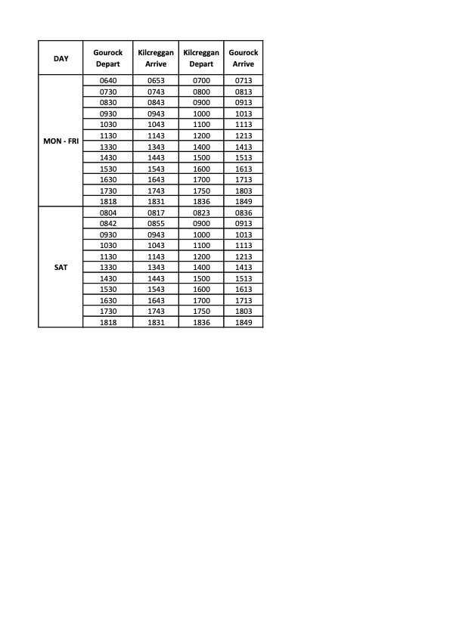
Having recently conducted a public consultation on the proposed summer timetable, the finalised version has been published by CalMac and is attached. The intended timetable is designed as far as possible to connect with trains, buses and the Dunoon ferry. It reflects local input and, with departures mainly on the hour or half hour, should be simpler to understand.
CalMac have now launched a network wide consultation on winter ferry timetables, but in the case of the Kilcreggan ferry, there is no difference between the summer and winter. Unless we hear significant objections, the Community Council will propose to CalMac that the winter 2024 timetable should be the same as the summer.
The winter timetable consultation closes on 12th Ferbruary.

