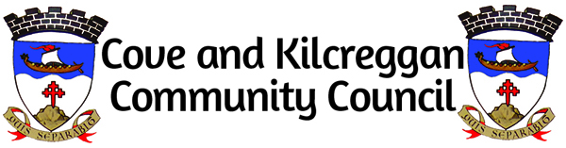

Cllr Andrew Kain Chair A&B Harbour Board
Hazel Macinnes Secretary to A&B Harbour Board
Michael Kean Transport Scotland Ferries Unit
Scott Reid A&B Council
2nd June 2023

Kilcreggan Pier - Kilcreggan Bay Option
Reference:
C&K CC Letter ‘Options for the development of Kilcreggan Pier’ dated 30th March 2023.
You will recall that I wrote on behalf of Cove & Kilcreggan Community Council (Reference A) expressing concerns about the proposed new development of berthing arrangements for the replacement ferry on the Kilcreggan-Gourock service (‘Option 4a’). Amongst the various objections raised by the local community there is concern that ‘Option 4a’ design does not take into account the impact on the Kilcreggan shore.
The local community greatly values our ferry service but we are keen that the future berthing solution for the replacement ferries integrates with our aspirations for village development. If a solution which makes use of the existing pier is not considered viable, we would prefer the replacement pier to be situated in Kilcreggan Bay.
The old stone pier, in Kilcreggan Bay just East of the existing pier, would be our favoured location for a replacement pier. The old stone pier forms part of the ‘Portkil Estate’ where options are being examined for development of the site. The landowner has indicated a willingness to make the old stone pier available as a basis for a replacement pier. He is also willing to provide public car parking which could be used by ferry passengers and recreational access to the beach. This has great potential for a good quality ferry terminal which could be very neatly integrated into the development of the village. An alternative option in Kilcreggan Bay would work really well for our community.
We would therefore like to see the option of using Kilcreggan Bay to be explored further. A transparent analysis of costs/benefits/challenges between using Kilcreggan Bay and the current proposal (4a) would be an important element of engaging with the community at an early enough point to enable real influence to be exerted in line with the National Standards for Community Engagement in Scotland.

Nicholas Davies
Chair Cove & Kilcreggan Community Council

Copy to:
Cllr Maurice Corry
Cllr Mark Irvine
Cllr Shonny Paterson
Cllr Fiona Howard
Jackie Baillie MSP

